Quarterly Report – Public Page

Date of Report: 5th Quarterly Report, September 27, 2024
Contract Number: 693JK32310013POTA
Prepared for: Government Agency: DOT and Co-funders
Project Title: Tank Foundation and Floor Designs and Best Practices for Improved Corrosion Control
Prepared by: Pipeline Research Council International (PRCI), Inc.
Contact Information: Janie Norton, jnorton@prci.org 703-205-1600 ext: 105
For quarterly period ending: December 31, 2024

1: Items Completed During this Quarterly Period:

Item # | Task # | Activity/Deliverable | Title | Federal Cost | Cost Share
1 | 1 | Kick-off web meeting with all stakeholders | Meeting minutes and a Summary of the Literature Review to be included in the  quarterly report | $34,863 | $8,716
3 | 2 | Facilitated Meetings/Data Mining of Operator-Industry Tank Designs, Corrosion Prevention, Monitoring and Leak Detection. | Summary of the industry tank designs and corrosion prevention and Leak detection and Release Prevention performance will be included in the quarterly report | $68,277 | $17,069
5 | 3 | Research on Release Prevention and Leak Detection Practices and Equipment | Summary of Findings On Leak Detection and Release Prevention to be included in the quarterly report | $43,572 | $10,893
10 | 5 | 5th quarterly status report & project management | Submit 5th Quarterly Status Report | $11,618 | $2,905

2: Items Not-Completed During this Quarterly Period:

Item # | Task # | Activity/Deliverable | Title | Federal Cost | Cost Share
7 | 4 | Developing Guidance on Best Practices for Sealing Tank Bottoms to Prevent Water and Foreign Material in Single and Multibottom Tanks. | Summary Report of Findings on Best Practices For Sealing Tanks to be included in the quarterly report. | $36,276 | $9,069
9 | 5 | Initiate Research Review on Improvement of Corrosion Control and CP on New and Existing Tanks and Tanks with Solid Pad Materials and Final Report | Draft Summary of guidance on Corrosion Control Matrix for Tank and Tank Pads will be included in the quarterly report. | $25,356 | $6,339

3: Project Financial Tracking During this Quarterly Period:

Note that this chart reflects Federal share only:

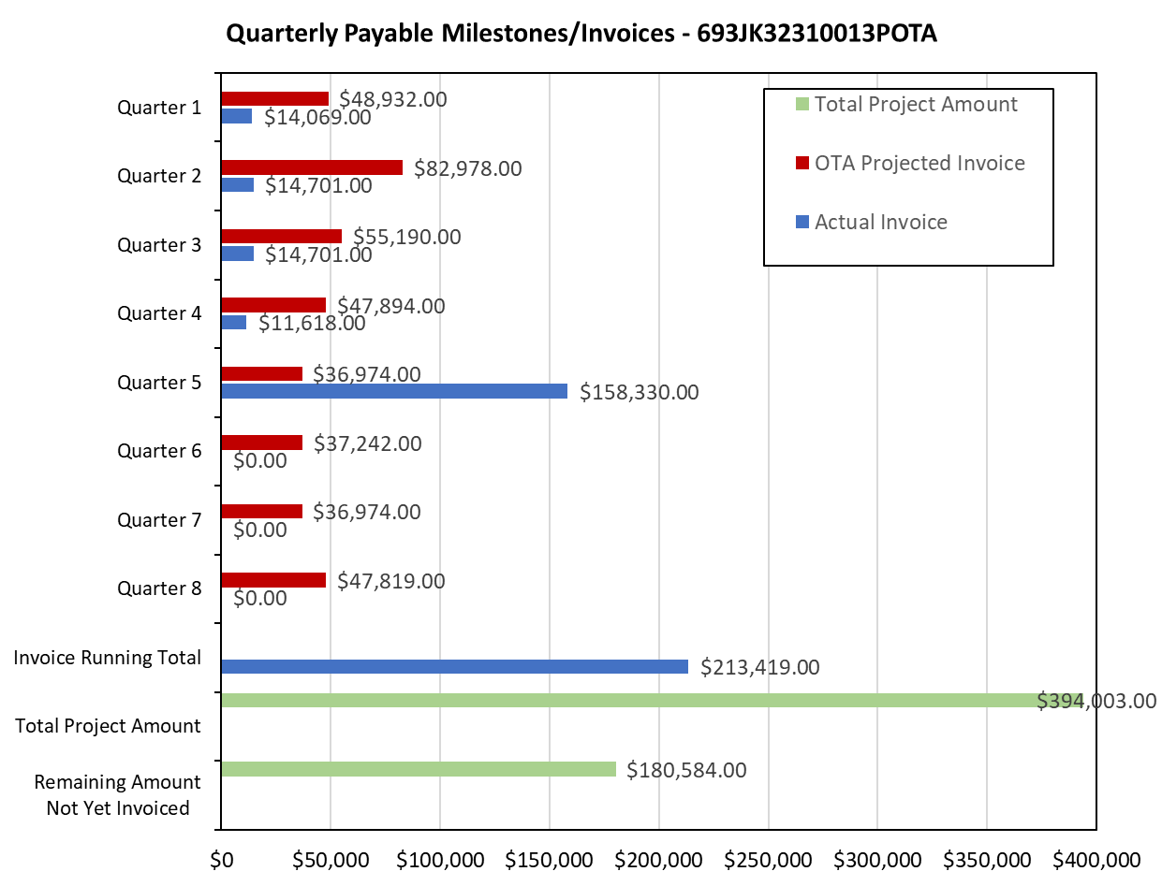

4: Project Technical Status –

Task 2 - Facilitated Meetings/Data Mining of Operator-Industry Tank Designs, Corrosion Prevention, Monitoring and Leak Detection –Complete-Two surveys issued-surveys received-compilation and statistical analysis report completed. Deep Dive Facilitated Information Sessions completed, and Task 2 Report Updated.
Task 3 – Research on Release Prevention and Leak Detection Practices and Equipment Completed.
Task 4 - Best Practices for Sealing Chime and Double Bottom Tanks. Summary report to be completed 1-3-25.

5: Project Schedule –

The project schedule issues resolved.

